Project Design Phase-II
Technology Stack (Architecture & Stack)

Date | 02 November 2025
Team ID | NM2025TMID00562
Project Name | Laptop Request Catalog Item
Maximum Marks | 4 Marks

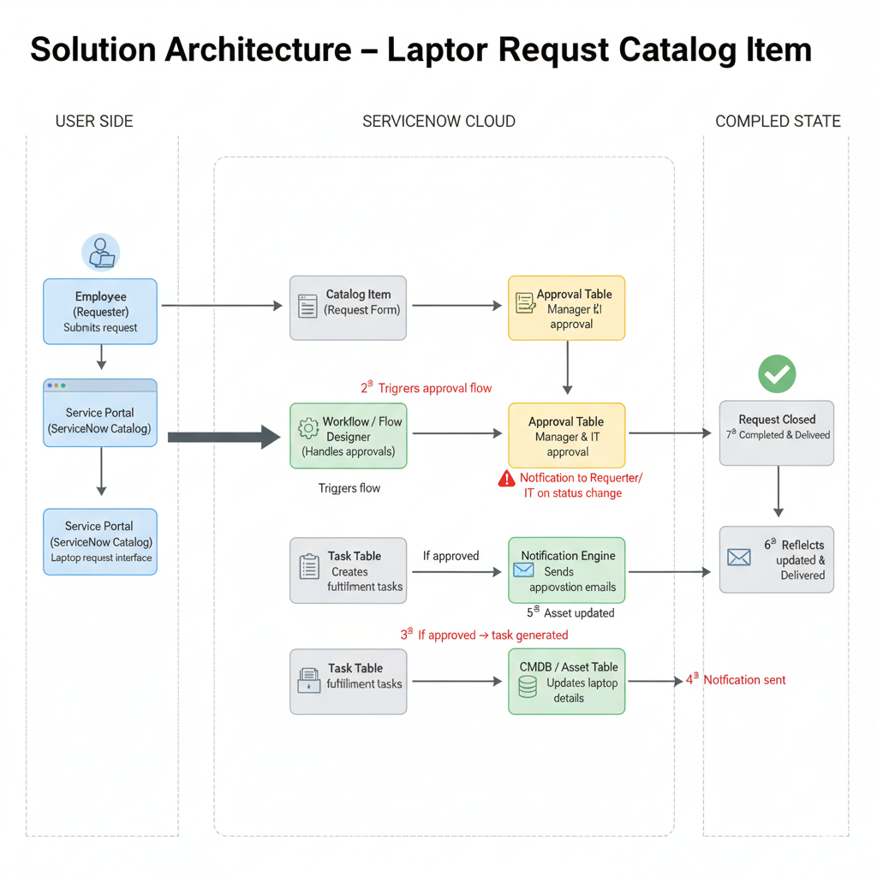

Table-1: Components & Technologies
S.No | Component | Description | Technology
1. | User Interface | Employees, managers, and IT staff interact via the ServiceNow Service Catalog and dashboards. | ServiceNow Web UI
2. | Application Logic-1 | Handles submission of laptop requests and routes them for approval automatically. | ServiceNow Flow Designer
3. | Application Logic-2 | Manages approval flow and creates fulfillment tasks for IT after manager approval. | ServiceNow Flow Designer, Workflow Editor
4. | Application Logic-3 | Sends real-time notifications to requester, manager, and IT team on every status change. | ServiceNow Notification Engine
5. | Database | Stores request details, approval logs, and fulfillment records. | ServiceNow Tables (RITM, Task, Catalog Item)
6. | Cloud Database | Managed automatically through the ServiceNow Cloud Backend for all instance data. | ServiceNow Cloud Database
7. | File Storage | Minimal storage; logs and attachments maintained internally within the instance. | ServiceNow System Logs, Attachments Table
8. | External API-1 (Optional) | Integration with HRMS or Asset Management to validate laptop availability. | REST API in ServiceNow
9. | External API-2 | Optional integration with Email/Notification services. | ServiceNow Email Integration API
10. | Machine Learning Model | Not applicable for this use case (manual approval-based workflow). | -
11. | Infrastructure (Server / Cloud) | Hosted and managed under the ServiceNow SaaS (Software as a Service) model. | ServiceNow Cloud (SaaS Platform)

Table-2: Application Characteristics

S.No | Characteristics | Description | Technology
1. | Open-Source Frameworks | Not applicable (ServiceNow is a proprietary cloud platform). | -
2. | Security Implementations | Role-based access control (RBAC), ACLs, and secure scripted access for approvals and task management. | ServiceNow Access Control Lists (ACLs), Scoped Apps
3. | Scalable Architecture | SaaS-based, horizontally scalable, supports increasing number of requests and users. | ServiceNow Cloud Architecture
4. | Availability | Highly available system with guaranteed uptime and redundancy under ServiceNow hosting. | ServiceNow Cloud Infrastructure
5. | Performance | Optimized through asynchronous flows, indexed tables, and background processing for smooth workflow. | GlideRecord, Flow Designer, Background Scripts

